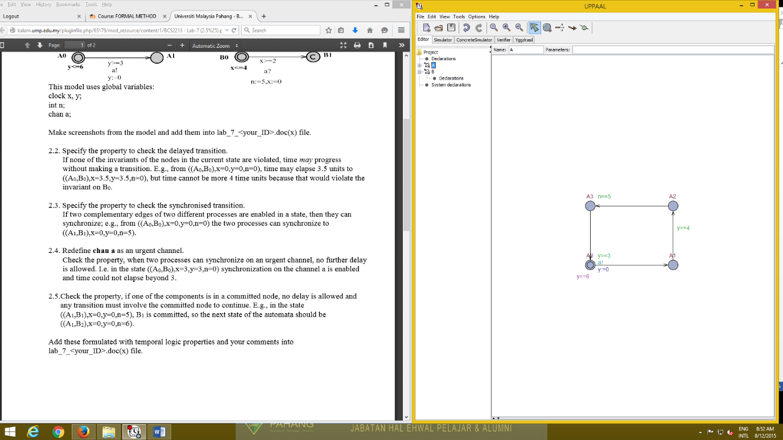Labsheet 7_CB14139

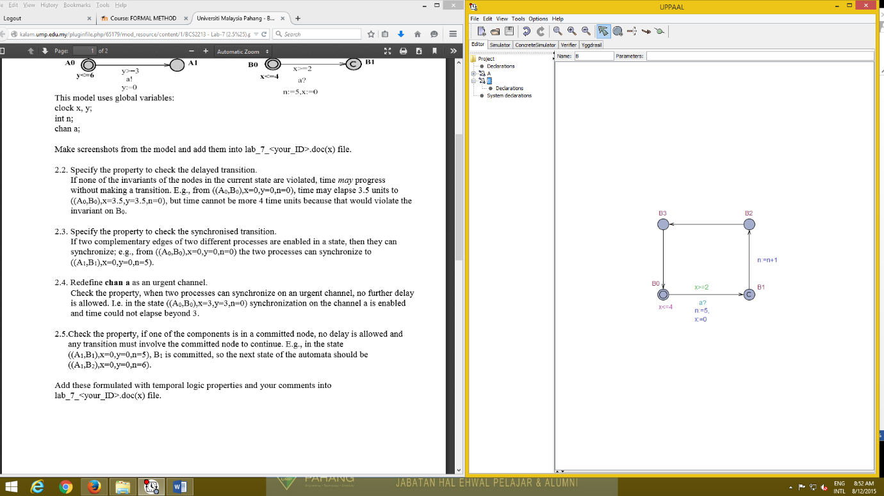2.1

2.2. A0 can go to A1 from 0 ups to 6 but B0 can go to B1 if the times less than 4. I try put E<> y==3 and x==3 on the verifier and it is satisfied.

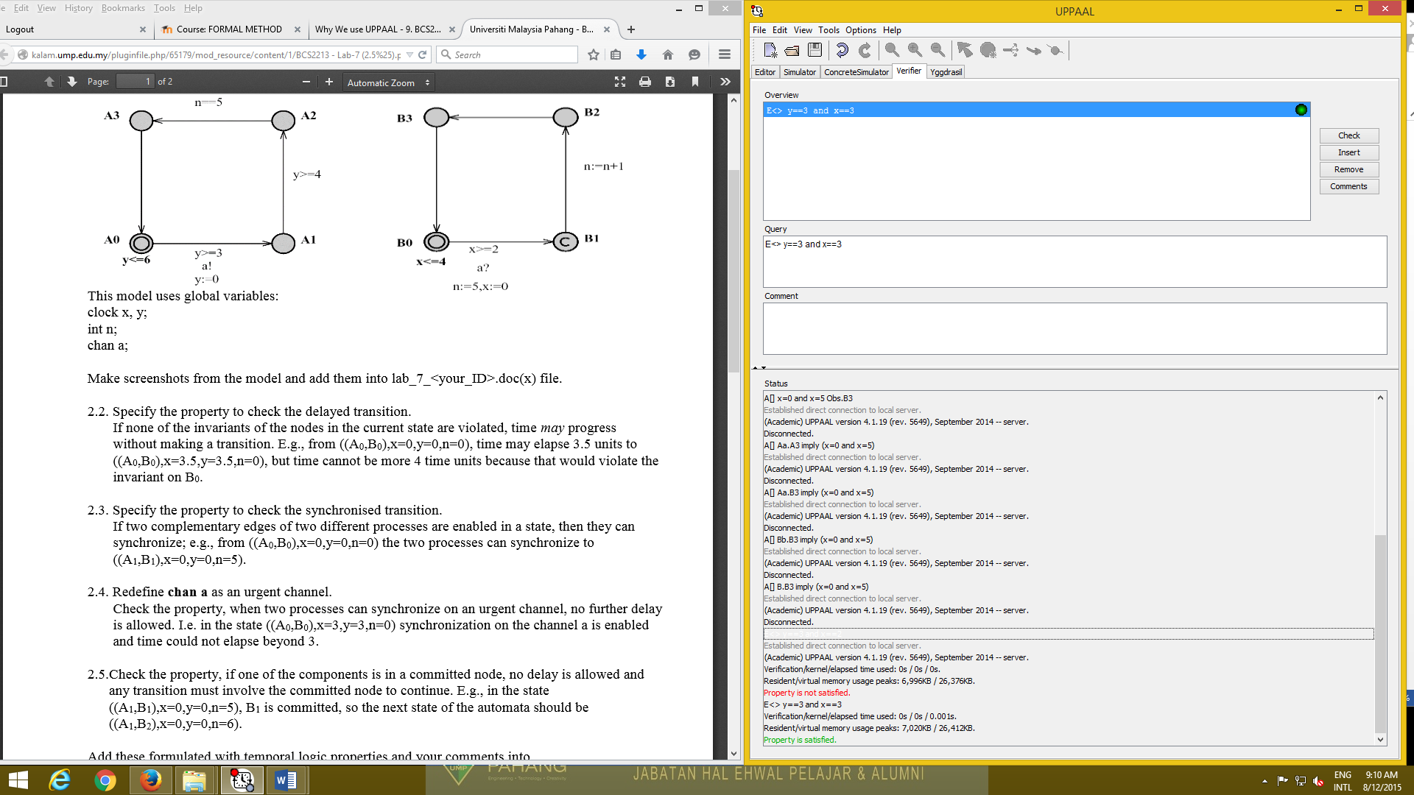

2.3. A0 go to B0 equal to x=0,y=0 and n=0. When A1 go to B1, the number of n will equal to 5 because the update is n:=5 so it plus 0+5=5 .

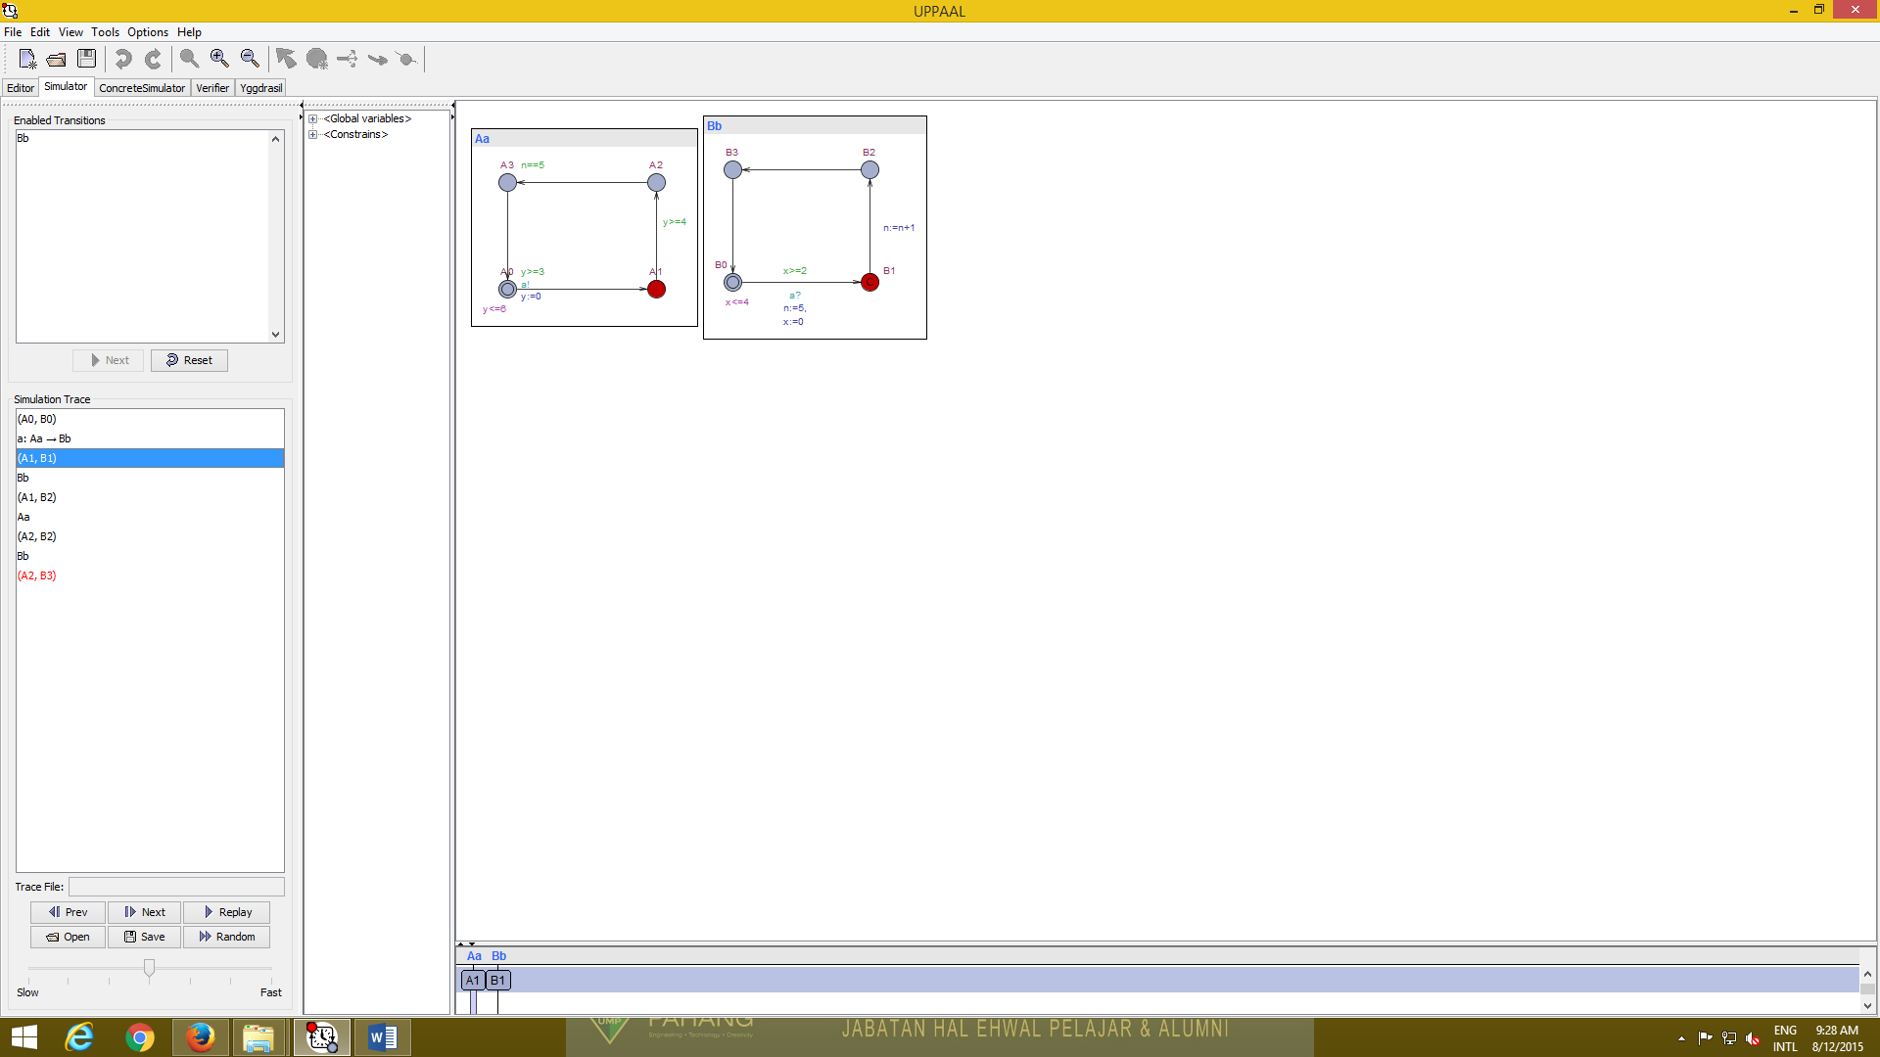

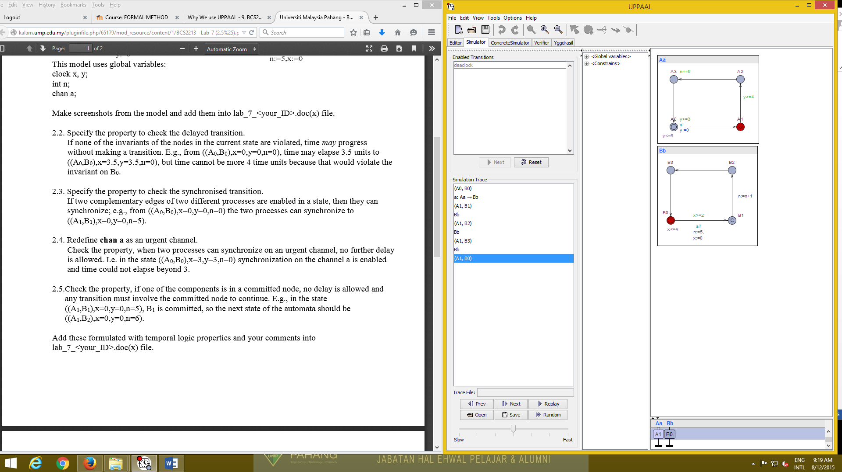2.4. Yes, if I add Urgent at A1, it is not elapse beyond 3. It just still at A1 like figure below and cannot go to A2.

2.5. A1 can go to B1 because n is equal to 5 and A1 can go to B2 because temporary n=5 plus 1, so it will be n=6. It is pass because the deadlock will happen if n is more than 6.

